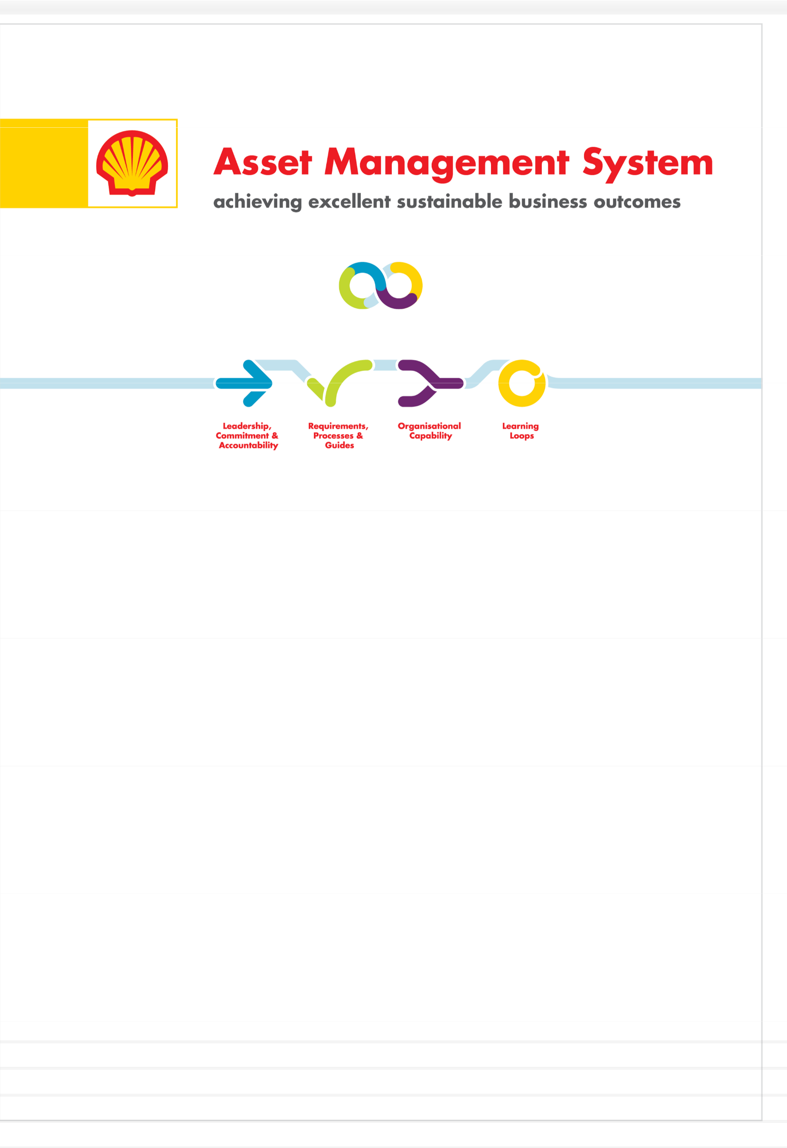

MTO - Manage Threats and

Opportunities

Recommended Practice

Non-Mandatory Restricted

Version MTO_RP_01_v1 15 June 17

## Copyright 2017 SGSI B.V.

The copyright of this document is vested in Shell Global Solutions International B.V., The Hague, The Netherlands. All rights reserved. Neither the whole nor any part of this document may be reproduced, stored in any retrieval system or transmitted in any form or by any means (electronic, mechanical, reprographic, recording or otherwise) without the prior written consent of the copyright owner.

### Contents

1. Purpose and Scope 3
   1. Purpose 3
   2. Scope 3
2. Process Activity Description 5
   1. Identify Threats and Opportunities 6
   2. Prioritise and Select 7
   3. Problem Solve 8
   4. Opportunity Framing 9
   5. Take Action 10
   6. Learn and Improve 10
   7. Process Execution 11
      1. Short Term Threat/Opportunity Management 11
      2. Long Term Threat/Opportunity Management 11
      3. Complex Problem Solving 12
3. Key Work Process Interfaces 15
4. Performance Indicators 16
5. Glossary 17

Appendices 20

Appendix 1: Reference Material 20

Appendix 2: Problem Solving 21

Appendix 3: Reasoning 24

# Purpose and Scope

# Purpose

The purpose of the Manage Threats and Opportunities (MTO) RP is to supplement the Asset Management System (AMS) MTO Standard and Manual. It outlines the practical steps of the work process, keys to successful execution, defines key terms and gives examples of “what good looks like”.

# Scope

This RP describes each step of the process activity from identifying threats and opportunities through to learning and improving. It also describes the structure needed to manage short and long term threats and opportunities effectively as well as the complex ones that require additional time and Enhanced Problem Solving Teams.

MTO is one of the enabling processes for an efficient, reliable and optimised organisation as shown in Figure

1. Regular operation and maintenance of an Asset through the execution of standard work processes will serve as the primary feed into the MTO process. Outputs from the processes will inform and improve how the Asset operates in the future.

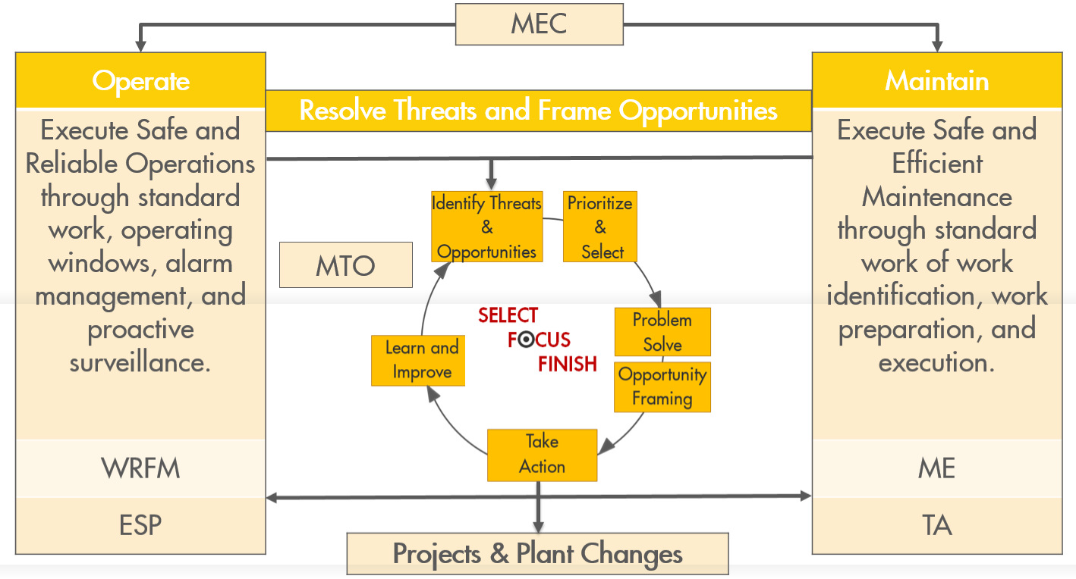

**Figure 1: MTO as an enabling process**

Keys to Success

* + Leadership - leaders participate actively in the process to ensure effectiveness and provide the necessary governance.
  + Performance Monitoring – strong use of visual management tools and continuous improvement methodology to measure, display and analyse Asset performance (equipment, production and work process).
  + Threat/Opportunity Management - threat and opportunity identification is part of standard work. There is clear integration between work process outputs and MTO, and threats/opportunities have clearly defined ownership.
  + Goal Setting - organisational leaders set clear objectives pertaining to threat mitigation and opportunity realisation, i.e. how many, who will do it and by when.
  + Problem Solving - the organisation has strong causal learning capability, invests in development and is structured to solve problems of varying levels of complexity.
  + Disciplined Delivery - the organisation has strong execution capability, will focus on the few and deliver through an end-to-end process.
  + Learning – understanding the causes of current performance and the role individuals play in creating the performance is necessary to improve performance.
  + Collaborative Dialogue - Transparent reasoning and exchange of ideas for problem solving and improved understanding

# Process Activity Description

The process activities are shown in the MTO cycle in Figure 2. They provide a framework to enable an Asset to improve and sustain performance through:

* regular identification of performance threats and opportunities
* prioritization of work on the high risk/high value items
* rigorous problem solving and opportunity realization to ensure robust action plans are developed, monitored and executed.

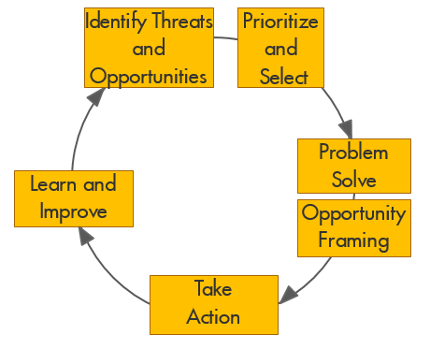

**Figure 2: MTO process**

Meeting Structure

A consistent meeting cadence enables the MTO process and involves all levels of the organization. While many of the meetings needed to discuss threats and opportunities can be combined with other scheduled meetings, setting time to review and discuss threats and opportunities on a recurring basis will allow for a robust process. Figure 3 outlines the meeting cadence and levels of governance within an Asset along with key topics for each meeting.

*Note: Figure 3 shows only the core MTO meeting structure. Requirement for the quarterly meeting depends on the organization size (single Asset or multiple Assets / directorate). Intent is to integrate MTO meetings into the existing meeting structure as much as possible. In addition, supporting meetings may be required.*

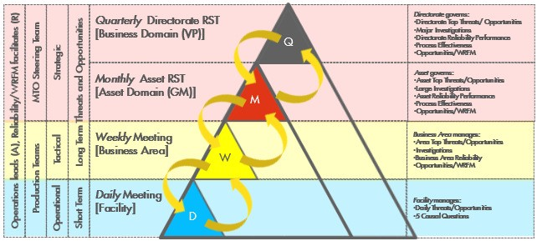

**Figure 3: MTO meeting cadence**

# Identify Threats and Opportunities

The objective of this activity is to review Asset performance and work process outputs enabling identification of threats to the business plan and Asset strategy as well as identification of opportunities to improve any aspect of Asset performance.

Threats and opportunities can come from any source. The most common sources are reviews of Asset performance metrics and standard work process outputs. These can include:

* + - HSSE Performance

Note: Threats identified through the assessment of HSSE performance data should be captured in the MTO Process

* + - Hazards and Effects Management Process (HEMP), e.g. identified critical barriers or activities
    - Wells, Reservoir and Facilities Management (WRFM) Practice Table Review Process – any opportunities or threats that result from the structured review of the Wells and Facilities through the WRFM practice table, e.g. Production System Optimisation, Asset Facility Review, Well and Reservoir Review
    - Ensure Safe Production (ESP) – shift handovers, shift reports, start of shift orientation results, shift team plans and results of proactive shift and technical monitoring
    - Actual Production Performance vs. Operating Plans, e.g. throughput, flaring, quality, gas and water injection quality, yields, energy, etc.
    - Actual Equipment Performance Vs Standards and Requirements, e.g. pumps, piping, instrumentation, exchangers, systems, etc. that frequently has a negative influence on Asset reliability, process safety, environmental, reputation, or cost performance; may also cause significant organisational distraction
    - Threats/opportunities identified from other work processes – see Key Work Process Interface (Section 3)
    - Proactive Threat Identification Engagement (PTIE) and Asset Infrastructure Assessment (AIA). See Appendix 1.

The following points are key to success.

* + - The organisation monitors work process performance constantly.
    - The organisation measures and evaluates production and equipment performance constantly.
    - Performance data and expectations are visible and understood by all.
    - All levels of the organisation identify threats and opportunities actively.
    - The organisation promotes proactive threat identification activities.
    - Threats and opportunities are supported by performance data.
    - The MTO Tool is used as a single repository for all long term identified threats and opportunities.

# Prioritise and Select

The objective of this activity is to select:

* + - short term threats and opportunities for resolution based on the assessment of the Production Team and within its capability to resolve. These are threats or opportunities that, typically, take less than 30 days to manage and, typically, do not have an MTO score.
    - long term threats and opportunities for resolution that are aligned with the local business plan and/or broader Asset strategy. These are threats or opportunities that, typically, take greater than 30 days to manage and have an MTO score.

To meet the objective the following activities should be carried out.

* + - Capture all short-term threats and opportunities along with the action on a “whiteboard”.
    - Enter all long-term threats and opportunities into the MTO tool and complete the MTO scoring.
      * Select threats and opportunities for resolution based on the MTO score and local business objectives or broader Asset strategy. This can, typically, be done for long term threats/opportunities at the weekly/monthly meetings.
    - Review threat and opportunity MTO scores for consistency on a regular basis.
    - Agree a prioritised list of threats and opportunities for the unit or area.
    - Assign each threat and opportunity to a single owner, i.e. typically a member of the Production Team.
    - Decide what analysis is needed, e.g. is an investigation or assessment required?
    - Agree on the prioritised list of threats and opportunities for the Asset The following points are key to success.

Short Term

* + - Prioritisation and selection is based on the assessed impact (actual and potential) to the near term business objectives:
      * Production Team to determine impact
      * priority assigned based on impact and resource availability.

Long Term

* + - Prioritisation and selection is based on the assessed impact (actual and potential) to the business objectives and/or broader Asset strategy and organisational capacity:
      * the MTO Tool is used to determine the business impact
      * many threats and opportunities will not be worked due to low priority.
    - All threats and opportunities are assigned an owner (lead).
    - There is a prioritised list of threats and opportunities for each operational unit or area and a prioritised list for the broader Asset:
      * ensure work priority is aligned with the business objectives and broader Asset strategy.
      * There are clear objectives pertaining to threat mitigation and opportunity realisation, e.g. how many, who will do it and by when.
    - Threats and opportunities are reviewed regularly.

# Problem Solve

The objective of this activity is to understand the causes of threats sufficiently to develop corrective action plans to improve performance sustainably.

Problem solving, in a performance improvement context, stresses that an organisation needs to understand the causes of discrete events in time as well as larger performance problems and opportunities that can span a broad time frame, e.g. unrealised capacity, low reliability, repeat failures etc.

The problem-solving cycle is shown in Figure 4.

### 

Assess Effectivness

Frame Problem

Develop Mitigation (if needed)

Take Action

Investigation

Develop Action Plan

Solution Development

**Figure 4: Problem solving cycle**

Short Term Cycle

The short-term cycle is biased toward action and is focused on fixing daily operational problems needed to meet the near-term production plan, while assessing operational efficiency continuously. Action plans are developed by the frontline and/or Production Teams and are executed quickly using resources available to the local business leaders (OM/PUM). Within the short-term cycle, action is developed and executed based on the existing knowledge and experience of the Production Team.

Long Term Cycle

The long-term cycle is focused on performance improvement where problems are sufficiently understood to enable action to be taken to address specific causes and achieve long term sustainable improvement. Corrective action plans are developed after an investigation is completed and causes are clearly understood and are executed by local resources or the execution teams within Projects or Turnaround organisations. Within a long term cycle, mitigation is often needed to prevent or reduce the likelihood of the threat materialising before longer term corrective action can be developed and implemented.

To meet the objective, the following activities should be carried out.

* + - Decide on the specific aspect of the threat requiring an analysis.
    - Decide on the purpose of the investigation, i.e. what you want to find out. Typically, the purpose of an investigation is to find out why something has happened or is happening (discover the causes).
    - Decide on the level of resourcing needed to achieve the desired outcome:
      * Enhanced Problem Solving Team (EPST) o Production Team/Technical Resources o Front Line.

Conduct an investigation to meet the intended purpose. Refer to Appendix 2 for more information on Problem Solving.

* + - Learn from the investigation, i.e. what was discovered. Share findings with the Production Team and discuss insights.
    - Decide on the desired performance outcome, i.e. what you want to achieve.
    - Develop final solutions to attain the desired performance outcomes. The following points are key to success.
    - Causal Learning is the preferred methodology used for problem solving.
    - The organisation and its leaders have strong Causal Reasoning capability.
    - Problem solving occurs at all levels of the organisation.
    - Leaders are accountable for ensuring the proposed action is corrective and it gets implemented.
    - Problem solving activities focus on near term fixes and longer term performance improvement.
    - The MTO Tool is used to document and record investigative decisions.
    - The organisation has the capability to solve problems with varying levels of complexity.

# Opportunity Framing

The objective of this activity is to select the solution with the highest cost/benefit that delivers the desired performance outcome.

Opportunity Framing stresses that the organisation should realise small improvements, (“quick wins”) as well as manage larger opportunities that can span a broad time frame. In both cases, the organisation must frame the opportunity, define success criteria and understand the likelihood of success sufficiently before developing action plans and understand what success looks like.

The following activities should be carried out.

* + - Define the opportunity and its potential cost/benefit (production, safety, financial, etc.).
    - Determine success criteria, i.e. what would have to be true or in place to realise the opportunity.
    - Conduct an assessment to select a solution which will deliver the desired performance outcome.
    - Share the assessment findings with Production Team, i.e. what was discovered.
    - Develop long term solutions to attain the desired performance outcomes. The following points are key to success.
    - Opportunities are framed in the context of the local business objective or broader Asset strategy.
    - Opportunity realisation occurs in all levels of the organisation.
    - Success criteria are described and commonly understood by the organisation.
    - The organisation understands the likelihood of realisation and the value proposition.
    - Leaders are accountable for ensuring proposed action will maximise return on investment.

# Take Action

The objective of this activity is to execute agreed action items to resolve performance problems and to realise opportunities for Asset improvements.

To meet the objective the following activities should be carried out.

* + - Develop specific, time bound actions to achieve an agreed solution and input them into MTO Tool/”Whiteboard” with assigned owner.
    - Clarify when the actions need to be executed, who will execute them and how they will be funded.
    - Execute action in agreed timeframe. The following points are key to success.
    - Action items are endorsed by leadership.
    - Action items have a clear owner, budget and execution plan.
    - Success criteria are described and commonly understood by the organisation.
    - The organisation understands the likelihood of realisation and value proposition.
    - The organisation has strong execution capability and a clearly defined process for it.
    - There is a clear distinction between corrective action and action that will close a gap to a business requirement.
    - Focus is on the actions that would make the biggest difference.
    - Action items are actively managed to ensure completion, e.g. whiteboard for short term and MTO Tool for long term.

# Learn and Improve

The objective of this activity is to assess the effectiveness of the action taken to determine if the desired outcome was achieved (did we do it and did it work) and to improve understanding of the equipment, including wells and facilities, and the system in which the action was taken.

To meet the objective the following activities should be carried out.

* + - Assess effectiveness of implemented solutions:
      * check to see if all agreed actions have been completed
      * compare the outcome of all actions taken to what was expected (the desired outcome).
    - Capture and discuss insights from the solution effectiveness review.
      * Develop new understanding based on personal and collective insights, discuss how things work now and engage in a larger dialogue to align understanding. Be sure to include the reasoning and evidence used to develop the new understanding. Refer to Appendix 3 for more information on Reasoning.
    - Share successes in opportunity realisation and threat mitigation.
      * Review the MTO Tool for local applicability of other Assets’ threats and opportunities. See the link to Global Threats List in Appendix 1 for an example of a proactive threat identification.

The following points are key to success.

* + - Learning is viewed as a shift in understanding or perspective to align more effectively with the current operating context.
    - Learning about how action is created as well as the system in which the action is taken is viewed as a necessary step in improving performance.

# Process Execution

Successful threat and opportunity management within an organisation will, typically, have two distinct cycles and objectives. The first is short term management focused on action plans that are developed by the frontline and/or Production Teams and are executed quickly (<30days). The second is long term management focused on longer term threats and opportunities where action is developed after an investigation or assessment.

## Short Term Threat/Opportunity Management

Threats and opportunities that can be resolved/realised in the near term (~30 days or less) with resources available to the local business leader (OM/PUM) should be framed and managed using Short Term Threat/Opportunity Management.

Activity

During the Production Team’s scheduled daily production meeting, Asset performance is discussed with a specific focus on:

* + - * identifying threats to the near term operational plan
      * identifying opportunities to improve current production profile or equipment performance
      * when an identified threat/opportunity is deemed to be credible, the OM/PUM should assign an owner accountable for leading the resolution activity
      * the threats/opportunities identified should be captured on a whiteboard and reviewed until the threat is resolved; the whiteboard should contain the following information:
        + threat/opportunity title
        + threat/opportunity progress description
        + date added
        + threat/opportunity owner
        + action
        + target completion date

*Note: Production Team should analyse any evidence associated with the problem prior to developing action – Use the 5 questions in the causal reasoning entry in the Glossary as a guide.*

* + - * OM/PUM escalates all threats/opportunities requiring additional resources to the MTO Steering team for resolution
      * Production Team removes the threat/opportunity from the whiteboard when threat/opportunity has been resolved/realised.

Structure and Resources

* + - * Performance data and visuals.
      * Daily production meeting includes the discussion of threats to Asset performance.
      * “Whiteboard” to record identified threats and opportunities and associated action.

## Long Term Threat/Opportunity Management

Threats and opportunities needing more time or resources to resolve/realise (>30days) should be framed and managed using Long Term Threat/Opportunity Management.

Activity

* + - * Production Team records the identified threats and opportunities that have been escalated from Short Term Threat/Opportunity Management in the MTO Tool.
      * Technical support organisations review and assess Asset performance data regularly, i.e. PTM, WFRM, etc. and frame specific threats and opportunities based on local and global standards, requirements and expectations. The technical support organisation then records applicable identified threats and opportunities in the MTO Tool.

*Note: All threats and opportunities are assessed and scored in the MTO Tool. The MTO score can be re-assessed as additional information is made available, which may or may not affect the priority of the threat/opportunity.*

* + - * OM/PUM decides which threats/opportunities to progress.
      * Production Team aligns on list of threats and opportunities to be worked based on prioritisation.
      * OM/PUM assigns single point responsible threat or opportunity owner.
      * OM/PUM decides if mitigation is needed. Mitigation is temporary action taken to bridge the current operating condition to the final solution.
      * If mitigation is needed, the threat owner develops a plan and to include:
        + a description of the specific required outcome
        + the duration of the mitigation
        + a description of how the mitigation will work
        + the detailed steps needed to implement the mitigation plan
        + the aspects of the mitigation plan that require monitoring or assurance
        + record mitigation in the MTO tool
        + PUM/OM to approve the mitigation plan.

*Note: Mitigation should remain in place until the threat is resolved or if the situation changes and the threat is no longer valid.*

* + - * Using Causal Reasoning, investigate or assess as needed.
      * Threat owner to share findings of the investigation or assessment with the Production Team.
      * OM/PUM to decide what will be addressed and describes the desired outcome.
      * Threat/opportunity owner develops and shares solution with the Production Team.
      * OM/PUM approves solution and associated action plan, and where applicable, the Technical Authority provides assurance.
      * Execute action plan and monitor outcome to validate if threat/opportunity has been realised/resolved.
      * Threat/Opportunity owner to discuss solution progress regularly with the Production Team and close the threat/opportunity when OM/PUM determines that it has been resolved/realised.
      * Regularly review low-risk score threats and threats that were not actioned to validate these threats are still prioritised properly (minimum annually).

Structure and Resources

* + - * Performance data and visuals.
      * Skilled MTO practitioner, e.g. site process focal point, reliability engineer, WRFM lead, etc. to work with the Production Team.
      * Weekly and/or monthly meeting to discuss threat/opportunity status.
      * MTO Tool.

## Complex Problem Solving

Highly complex threats, i.e. threats associated with complex equipment, repeat failures or threats that have or is having a significant impact to the business plan often require more time and resources than can be afforded by the Front Line or Production Teams. An Enhanced Problem Solving Team (EPST) is often created within the technical organisation, permanently resourced and highly skilled in the Causal Learning Methodology to help understand the causes of these complex problems and work with the Production Team to develop corrective action. For additional information see the Causal Learning Recommended Practice.

Activity

* + - * Work with the Production Team and Sponsor (OM/PUM, Discipline/Functional Lead, or other Business leader) to understand the nature of the complex threat/problem they are assigned and the purpose of the investigation.
      * Use the Causal Learning Methodology to discover the causes of the problem and help the Production Team learn from what was discovered.
      * Work with the Production Team and Sponsor to develop corrective action.
      * Load investigation decisions and actions into the MTO tool.

*Note: In some situations, the EPST may be requested by the organisation to lead the implementation of corrective action. This is possible if the action and execution plan is supported by the business leaders (OM/PUM).*

Structure and Resources

* + - * Permanent Team reporting to the technical/reliability organisation.
      * Dedicated work space for the team.
      * Members skilled in Causal Learning Methodology.
      * Governance Structure to manage how work is assigned to the EPST and how recommendations and actions connect to the Production Team for execution.
      * Team has a sponsor, e.g. member of the senior leadership team.
      * Team has a support structure for coaching and development (problem solving coach).
      * Team has a clear succession plan to ensure members transition in and out while the team is still able to function (avoid wholesale change out of team members).

Roles and Responsibilities

*MTO Steering Team*

* + - * Provide the necessary oversight to ensure threats and opportunities being worked have the right priority, i.e. (aligned with the overall business objectives or broader Asset strategy.)
      * Ensure threat mitigation and opportunity realisation is occurring at the right pace, i.e. (work is progressing as needed.)
      * Decide what complex threats are assigned to the EPST.
      * Ensures top threats and opportunities are cascaded to team members’ annual goals.

*Production Unit Manager/Operations Manager*

* + - * Validate MTO Score, their relative priority, and decide which threats and opportunities to progress.
      * Assign a single point responsible threat or opportunity owner.
      * Determine when mitigation is needed and accept all mitigation plans.
      * Decide what threats need an investigation and specify the purpose.
      * Determine when an investigation is complete.
      * Decide what must be addressed based on the investigation findings.
      * Define the desired outcome prior to taking action to mitigate a threat or realise an opportunity.
      * Ensure the proposed action is corrective and gets implemented.
      * Ensure threat mitigation and opportunity realisation activity is sufficiently resourced.
      * Decide when a threat or opportunity can be closed.
      * Escalate complex threats to the site MTO Steering team if additional support is needed.
      * Ensure top threats and opportunities are cascaded to team members’ annual goals.

*Functional Manager/Discipline Manager*

* + - * Drives alignment between threat mitigation/opportunity realisation priorities and other departmental activities.
      * Works with PUM/OM to validate alignment on threats/opportunities and their priorities, especially where team members support multiple Production Teams.
      * Maintains a list of top discipline threats and opportunities in their respective discipline.

*Threat/Opportunities Owner*

* + - * Single point responsible to ensure threat mitigation and opportunity realisation activities are progressing per in line with the plan.
      * Provides regular updates to the Production Team on threat/opportunity status.
      * Ensures the threat/opportunity details in the MTO tool are up- to- date.

*Reliability Engineer/WRFM Lead*

* + - * Provides MTO coaching to the Production Team as needed.
      * Leads opportunity/problem framing activities.
      * Leads MTO scoring activities to ensure consistency amongst threats/opportunities.
      * Facilitates weekly/monthly MTO update/progress meetings.
      * Takes a lead role to ensure data presented is representative of actual performance.
      * Provides Causal Learning coaching to threat/opportunity owners as needed.

# Key Work Process Interfaces

Interfaces with other processes are as follows.

|  |  |  |
| --- | --- | --- |
| Process | Inputs to Manage Threats and Opportunities | Ouputs from Manage Threats and Opportunities |
| Ensure Safe Production | Identified Threats and Opportunities | Proactive Monitoring Activities |
| Hazards and Effects | Identified Threats | HEMP Scenario Close-out |
| Perform Maintenance Execution | Identified Threats and Opportunities | Improved definition and prioritisation of work to be executed |
| Perform Turnarounds |
| Manage Equipment Care |
| Perform WRFM |
| Manage Projects | Identified Threats and Opportunities | Input into Identify/Assess, Select and Execute Phases of Project Work Process |

# Performance Indicators

These performance indicators are recommended in addition to the mandatory key performance indicators (KPIs) listed in the MTO Standard and Manual.

|  |  |  |  |  |
| --- | --- | --- | --- | --- |
| PI Category | PI Description | Leading / Lagging | Reference to  Reason for Metric  RP | |
| Identification/ Prioritisation/ Selection | # of LT Threats/Opportunities not risk scored >30days | Lagging | 4.2 | Provides insight into the health of the process |
| Take Action | LT Threat/Opportunity Cycle Time | Lagging |  | Demonstration of process health |
| # of overdue action items | Lagging | 4.5 | Measures ability to execute per plan |

# Glossary

Term Definition

Enhanced Problem Solving Team (EPST)

An EPST is a team of full-time members who have been relieved of their day-to-day duties and are used to solve the most significant problems being experienced that impair the business performance of the Asset(s) using the Causal Learning methodology.

An EPST has, typically, 4 members from different disciplines, e.g. Technology, Operations, Mechanical/Rotating, Control Systems.

The EPST is sponsored by a senior leader in the organisation, e.g. GM level or above.

The EPST members become skilled in Causal Learning methodology through training, coaching and experience.

Asset Asset is synonymous with Site in Downstream Manufacturing terminology.

Causal Learning is based on the premise that all undesirable performance outcomes were caused and that an organisation can improve future performance once it understands the causes of current performance problems, learns from the causes and takes action to address them.

Causal Learning

Causal Reasoning

The Causal Learning methodology is used to investigate incidents. An incident is an event or chain of events that resulted in an undesirable or unexpected performance outcome. The purpose of the incident investigation is to discover the causes of the incident, learn from the causes and to take corrective action to address the causes to improve the performance system that generated

the undesirable outcome.

In every day (simple) problem solving the Causal Learning principles are applied using the five causal reasoning questions.

1. What is the problem?
2. What do we think caused the problem?
3. What evidence do we have about the causes?
4. What solution(s) do we have in mind?
5. How will the solution(s) eliminate the causes of the problem?

The five causal reasoning questions can be used by an individual or group of individuals who are trying to solve a problem and understand how to reason causally.

Corrective Action

Long term Threats and Opportunities

Solving more complex performance problems typically requires a multi-disciplinary team who are skilled in the use of Causal Learning or who get help from a Causal Learning Facilitator.

Actions that address cause and creates a performance system that more reliably generates the desired performance

Threats to delivering, or opportunities to meet or beat the Business Plan commitments that typically require more than 30 calendar days to manage.

Term Definition

MTO Steering Team

Chartered by the Asset Manager/Site General Manager. The steering team is the governing team for MTO delivery and are responsible for:

* managing site wide threats and opportunities
* defining the strategy and schedule for the proactive threat and opportunity identification
* setting criteria for prioritisation and selection of threats and opportunities
* driving effective execution of the solution
* ensuring Business Plan build up adequately addresses key threats and opportunities
* monitoring the results of the implemented resolution.

Members may include Asset Manager, Site Process Owner, Asset Engineering Manager, Asset Maintenance Manager, etc.

MTO Tool

The tool utilised in the MTO process to document, prioritise, and track the mitigation status of long term threats and opportunities.

Any item that increases the Asset’s production or injection capability above the current system capacity, improves an Assets cost structure to meet or beat the current business plan, as well as any margin and/or CO2/energy-related that increases the site’s production capability above the current business plan. Examples include:

Opportunity

* Improvements to a crude desalter for increased crude flexibility.
* Catalyst change, adding a guard bed or adapting to allow processing of high Hg feedstocks.
* Using Ramen technology to control cutpoints and optimize yields/blends.
* Well interventions and/or facility modifications to increase Integrated Production System Capacity
* A reduction in cost below business plan.

Production Teams

Production Unit Manager (PUM) /

Operations Manager (OM)

Short term Threats and Opportunities

Threat

Multi-discipline members assigned to review the operating performance of a production unit or area, identify threats and opportunities, manage and communicate threats and opportunities, and follow-up on related action items. Members may include production day staff, production support, process engineering, inspection, maintenance, HSSE, Technology, discipline engineering, production chemistry, Well, Reservoir and Facility Management (WRFM), Economics and Scheduling (E&S) and laboratory. Production Team members may be own or contract staff and led by the Production Unit Manager/Operations Manager.

The individual accountable for the performance of the production unit/facility. The PUM/OM leads and works with the Production Teams and Shift Teams to review area status, manage threats and opportunities and resource recommended actions.

Threats to delivering, or opportunities to meet or beat the business plan commitments that typically require less than 30 calendar days to manage after identification.

Undesired outcomes (potential or actual) that can negatively impact the business objectives (local strategy).

Term

Definition

Threat and

Opportunity Owner

The threat and opportunity owner is the person designated as the single point responsible

person. The threats and opportunity owner acts as the “project manager” for their assigned threat or opportunity.

Whiteboard

A visual aid used by an Asset to display active short term threats and opportunities to

maintain alignment within the Production Team, e.g. dry erase board, electronic display, etc.

Well, Reservoir and Facility Management (WRFM) is one of the core components of upstream Wells, production excellence. It aims to increase our value delivery by economically improving Reservoir and recovery factors towards benchmarked TQ by applying and sustaining standard processes, Facilities data and systems, by building an engaged community of WRFM professionals and by using Management Lean principles to drive continuous improvement.

# Appendices

# Appendix 1: Reference Material

Below is a table showing an example of the correlation in the MTO phases and the ORP phases.

|  |  |
| --- | --- |
| ORP | MTO phases |
| Identify | Identify threats and opportunities |
| Assess | Prioritise and Select |
| Select | Problem Solve/Frame opportunity |
| Define | Take action |
| Execute |
| Operate | Evaluate, learn and improve |

**Table 1. ORP and MTP**

Links to Additional Reference Material:

* + Causal Learning: Additional Information on Causal Learning can be found in the AMS structure under the Causal Learning Recommended Practice: Link
  + Asset Infrastructure Assessment (AIA): The aim of the AIA activity is to establish and maintain an evergreen overview of Asset related threats for infrastructure Assets. Additional information can be found here: Link
  + Proactive Threat Identification Engagement (PTIE): Part of the Global Threats review where all threats for a specific technology are reviewed and placing them all in a single prioritised list that represents all the global threats for that technology. Additional information can be found here: Link
  + Enhanced Problem Solving Team (EPST): For additional information on establishing an EPST as well as ways of working and sustainability please see: Link
  + MTO Tool Guides: Information on how to enter, score and manage threats and opportunities in the MTO tool as well as interfaces with other tools (SAP-OM) can be found here: Link
  + Wells, Reservoir and Facilities Management (WRFM): One of the key enabling opportunity processes in Upstream. Additional Information on WRFM can be found here: Link along with additional Recommended Practices.

# Appendix 2: Problem Solving

Frame Problem

It is important to understand and align on the problem needing to be solved and writing the problem statement is the first step in this process. The problem statement represents the specific aspect of the problem needing to be solved helping focus the investigative effort. There are two types of problems to consider before writing a problem statement: discrete events and performance problems.

Discrete Events

* + If the problem is a discrete event in time, then describe the event using the Problem Statement structure Performance Problems
  + If the problem is a result of poor performance over time, then further analysis is need to determine what specifically needs to be understood and improved
    - Display historical performance data for the equipment or system in question with a specific focus on cost, deferment, and event frequency.
    - Events are those undesired outcomes like failures, leaks, trips, alarms etc.
  + Select the aspect of the performance problem needing improvement, this can be:
    - The aspect that has or is having the largest impact on performance, or
    - The aspect the Production Team feels it can improve, or
    - Both
  + Select a discrete event in time that best represents the aspect of the problem needing to be improved, recent in time and/or one that has sufficient data.
  + Describe the discrete event using the Problem Statement structure
  + Present selected problem to Production Team for alignment Problem Statement Structure
  + Expected: What was expected to happen prior to the event?
  + Actual: What actually happened (the event)
  + Impact: Consequence as a result of the event (potential and actual)

The Actual portion of the problem statement step will become the focus for the discovery phase Discovery

The Production Team must sufficiently understand what happened, how it happened and why it happened. This will allow for purposeful and relevant actions to be developed that solve problems and improve performance. The follow activities are necessary to sufficiently understand these steps of problems solving cycle.

What

* + Capture events occurring in time leading up to the event in question and display sequentially on a timeline (only include things that actually happened)
  + Make a list of what is known and unknown and develop data collection plan to improve understanding (further the development of the timeline)
  + Use timeline to develop insights about possible cause How

*Understand “How equipment functions”*

Determine and collectively understand how the piece of equipment or system being investigated actually functions and how it was designed to function as these can be very different.

* + Engage with those that operate the equipment and/or system as well as those involved in the design or technical support and assurance

*Understand “How work gets done”*

Determine and collectively understand how maintenance, operations, and technical groups interact with the equipment both generically and specifically. Clearly understand what they do, when and why.

* + Conduct interviews to understand how work happens pertaining to the equipment in question. Why

*Understand the “Why” (Discover Cause)*

* + Using the principles of Causal Learning, discover the causal paths (actions and conditions) that were necessary to result in the undesired outcome (cause and effect diagram).

Learning

Learning or making meaning form the causes discovered is an essential step for the Production Team prior to developing corrective actions as it provides an opportunity for the team and leaders to understand what is or was causing their problem. Usually the causes of problems are different than were expected and the organisation needs time to makes sense of these new discoveries, both individually and collectively. When this happens, the solution ideas and in turn detail action plans will be different as the new understanding will cause new action that is necessary to improve.

Activity

* + Share discovered causes along with supporting evidence and discuss as a team the things that are standing out or surprising.
  + As a team discuss new insights and perspectives that team members have about the equipment or system.
  + Based on this new understanding, identify the cause that must be addressed Solution Development
  + Describe the desired performance outcome (what you want to achieve)
  + Develop solution Ideas and specifically describe HOW they will address the selected causes and achieve the desired outcome. Present solutions ideas to Production Team for alignment.
  + Test solution to ensure that the solution is corrective Action
  + Develop specific time bound action items to achieve the agreed solution
  + Gain endorsement form area leaders
  + Assign each action item a specific owner
  + Complete all actions to ensure the solution is achieved Problem Escalation

As the complexity or severity of a problem increases more time is often needed to understand the problems, discover cause and work with the organisation to develop corrective action. The figure below represents a recommended structure to allow the escalation of problems solving within an organisation.

* + Leaders are accountable to ensure problems are escalated and are appropriately resourced
  + A MTO Steering team will assure the escalation process and serve as the deciding body for complex problem solving activity
  + A MTO Steering team will review threats and opportunity status on a regular basis and assign work to the local EPST

### EPST



Problem Complexity

Production Team Front Line

**Problem Solving Escalation**

# Appendix 3: Reasoning

Objective

Reasoning is the foundation for MTO and provides consistency to it. Reasoning underpins each step in the MTO cycle.

Context

When we think and talk about problem solving and opportunity management most of the focus is on the detailed action plans we believe are needed to solve a problem or realise a particular opportunity. These action plans or ideas are generated from the conclusions we formulate based on how we understand the equipment or system and what we feel is an appropriate desired outcome. However, the thinking process involved in developing a conclusion is invisible and we often find ourselves defending or discounting a particular view without seeking to understand how those views and positions were developed. Exploring the reasoning behind a conclusion or action plan will reveal how the equipment and system is understood and provide insight into the desired outcome (what the action is trying to achieve).

*Note: Causal Reasoning is required when the desired outcome is performance improvement*

Developing Causal Reasoning skill within an organisation will improve threat and opportunity identification as well as the quality of proposed action. Teams will have a more focused and rigorous conversation about the assumptions and beliefs held regarding a threat or opportunity helping with validation as well as improving the level of certainty a particular action will work as intended.

Activity

Reasoning is about “connecting the dots” when presenting ideas or proposals. This assists in demonstration of what is understood and what is believed to be the best way forward. The following should be included when communicating ideas and proposals:

* + A clear description of the problem/opportunity
  + Experience/knowledge pertaining to the equipment or system
  + Beliefs pertaining to the equipment of system with supporting evidence
  + Success criteria
  + A description of how the proposed action will achieve the intended outcome